 | ALL SAINTS’ COLLEGE  Ewing Avenue, Bull Creek, Western Australia
 | human biology

Year 11 2008 - Semester II Examination - Question/Answer Booklet
C.C. STUDENT NUMBER - In figures 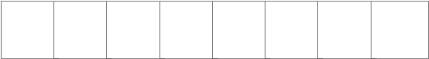

TIME ALLOWED FOR THIS PAPER
Reading time before commencing work: Ten minutes
Working time for paper: Three hours

MATERIALS REQUIRED/RECOMMENDED FOR THIS PAPER

TO BE PROVIDED BY THE TEACHER

This Question/Answer Booklet
Separate Multiple Choice Answer Sheet
Question Sheet for Part III
Standard 12 page Extended Answer Booklet

TO BE PROVIDED BY THE CANDIDATE

Standard items: Pens, pencils, eraser or correction fluid, ruler and highlighter.

Special Items: A 2B, B or HB pencil for the separate Multiple Choice Answer Sheet and calculators satisfying the conditions set by the Curriculum Council.

IMPORTANT NOTE TO CANDIDATES

No other items may be taken into the examination room.

It is your responsibility to ensure that you do not have any unauthorized notes or other items of a non-personal nature in the examination room. If you have any unauthorized material with you, hand it to the supervisor BEFORE reading any further.

STRUCTURE OF THIS PAPER

Part | No. of questions available | No. of questions to be attempted. | Marks available | Student’s Score
I Multiple choice | 40 | ALL | 80
II Diagram and short answer  questions | 9 | ALL | 80
III Extended answer questions: A  B | 2  2 | 1  1 | 20  20
Totals |  |  | 200

INSTRUCTIONS TO CANDIDATES

PART I Answer ALL questions, using a 2B, B or HB pencil, on the separate Multiple Choice Answer Sheet. Do NOT use a ballpoint or ink pen.

PART II Should be answered in this Question/Answer Booklet. Write your answers in the spaces provided, using a blue or black ballpoint or ink pen. Draw any diagrams in pencil.

PART III Should be answered in this Question/Answer Booklet. Write your answers in the Extended Answer Booklet, using a blue or black ballpoint or ink pen. Draw any diagrams in pencil.

PART I (80 marks)

Mark your answers to Questions 1-40 on the SEPARATE MULTIPLE CHOICE ANSWER SHEET, using a 2B, B or HB pencil. If you make an error, follow the instructions given to you on the answer sheet.

SELECT THE SINGLE CORRECT ALTERNATIVE IN EACH OF THE FOLLOWING QUESTIONS

- Older women on hormone replacement therapy (HRT) are at a higher risk of having a stroke. A stroke occurs in the

  - heart.
  - brain.
  - kidneys.
  - ovaries.

- Some smokers are susceptible to lung cancer due to a defect in their chromosomes. The component in cigarettes causing lung cancer is/are

- tar.
- nicotine.
- chemicals.
- DDT.

- AIDS can be a dangerous disease because

- a person dies very quickly once it is contracted.
- it is highly contagious and passed on by direct contact.
- it destroys the tissues of the nervous system of an infected person.
- it weakens the immune system so sufferers are vulnerable to other infections.

- The main role of bone marrow is

- producing blood.
- fighting infection.
- fat storage in the bone.
- producing blood cells.

Use the following diagram to answer Question 5.

Reproductive Organs

Process 1

Sperm Egg

Process 2
Zygote

Process 3

Embryo

- Process 1 would be termed

- mitosis.
- meiosis.
- fertilization.
- gametogenesis

- The female contraceptive pill contains hormones. When used correctly, the ‘pill’ will
- prevent a ovum being produced.
- decrease the secretion of the hormone oestrogen.
- prevent a fertilized egg from implanting.
- increase the blood levels of oestrogen and progesterone and stops menstruation.

- A screening test to determine whether young men are at risk of developing prostate cancer was used for the first time this year. A non-cancerous prostate’s main function in the body is

- producing semen.
- adding seminal fluid to the semen.
- producing alkaline solution.
- enhancing the erection process.

Use the diagram below to answer Question 8

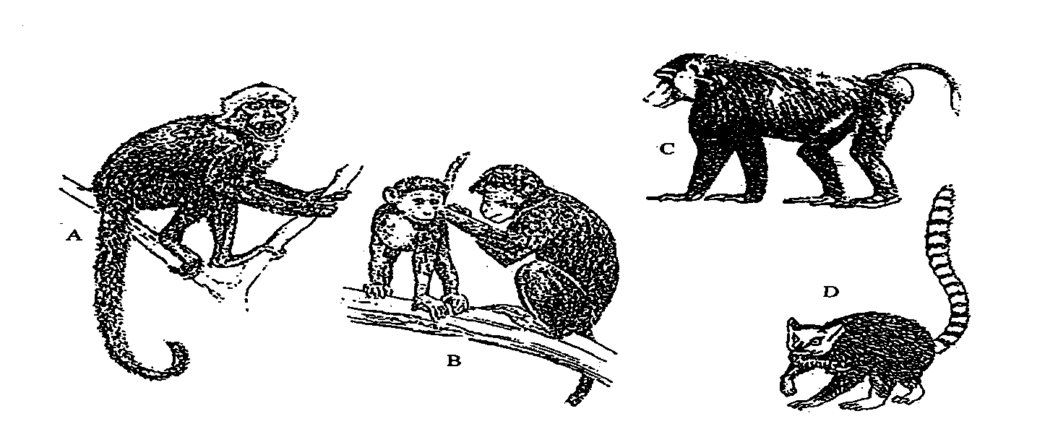

- Olfaction would be a very important sense in

- A
- B
- C
- D

- Gorillas belong to the following classification groups EXCEPT

- Anthropoid.
- Primate.
- Hominid.
- Pongid.

- Pentadactyl means

- five digits.
- the ability to grasp.
- five limbs including a prehensile tail.
- any five limbed primate.

- The muscles responsible for controlling the fingers in the precision grip are in the

- fingers.
- hand.
- thumb and palm.
- thumb and forearm.

- Which of the following statements regarding primate characteristics is INCORRECT?

- All primates have nails and friction ridges.
- All primates have an increased field of view.
- Most primates have a rhythmic sexual cycle.
- All primates have opposability of the first digit but generally unspecialized limb structure.

Use the diagram below to answer Question 13

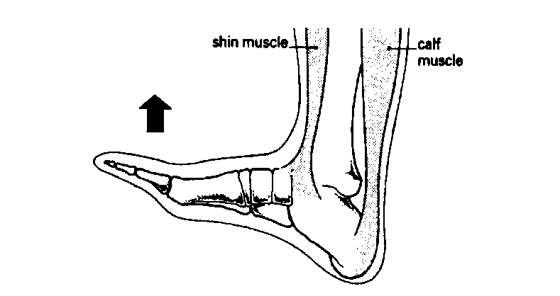

- The person moves his foot upwards as shown in the above diagram. This is because the

  - anterior tibilias contracts and the gastrocnemius relaxes.
  - anterior tibilias contracts and the gastrocnemius contracts.
  - anterior tibilias relaxes and the gastrocnemius contracts.
  - anterior tibilias relaxes and the gastrocnemius relaxes.

- Synovial joints are strengthened by
- tendons.
- articular cartilage.
- synovial membrane.
- ligaments.

- An example of a gliding joint in the body would be
- located in the thumb.
- found between the carpals in the wrist.
- located in the elbow joint.
- found between the humerus and the scapula.

- The stage or period of filling of the atria and ventricles of the heart with blood is termed

  - diastole.
  - pulmonary.
  - systole.
  - systemic.

- Blood or plasma does not usually come into direct contact with the cells. Exchange of nutrients and waste substances between the blood and the cells occurs through the

- arteries.
- lymph vessels.
- tissue fluid.
- capillaries.

Use the diagram below to answer Questions 18 and 19

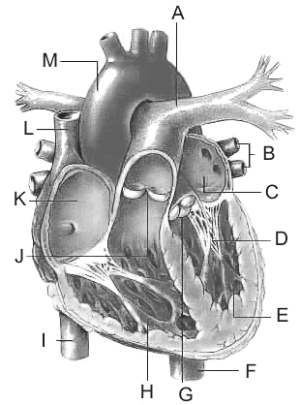

- A is the

- Pulmonary vein.
- Aorta.
- Pulmonary artery.
- Subclavian artery.

- G is the

- Bicuspid valve.
- Atrioventricular valve.
- Semi-lunar valve.
- Papillary valve.

- Which of the following pathways CORRECTLY describes the blood flow through the heart, lungs and body?

  - Right ventricle-right atrium-body-left atrium-lungs-left ventricle-body
  - Right atrium-left-atrium-lungs-right ventricle-left ventricle-body
  - Right atrium-right ventricle-lungs-body-left atrium-right atrium
  - Right atrium-right ventricle-lungs-left atrium-left ventricle-body

- Which hormone stimulates sperm formation?

- Luteinising Hormone (LH)
- Testosterone
- Follicle Stimulating Hormone (FSH)
- Oxytocin

- Progesterone secretion decreases sharply near the end of the ovarian cycle because

  - ovulation has occurred.
  - a mature Graffian follicle had been produced.
  - fertilisation has occurred.
  - the corpus luteum degenerates.

- Menstruation occurs when the oestrogen

  - levels are low.
  - levels are high and the progesterone levels are low.
  - and progesterone levels are both low.
  - levels are low and the progesterone levels are high.

- Intestinal villi

- increase the surface area on the intestines so the absorption of food can occur.
- moves food along the intestine easier.
- surround and digest the food particles.
- prevent food moving ‘backwards’ in the small intestine.

Use the following table to answer question 25

The chemical digestion of food occurs in the following parts of the digestive tract ( ).

Digestive System | Food 1 | Food 2 | Food 3 | Food 4
Mouth
Stomach
Small Intestine

- Which of the above foods is most likely to be mainly protein?

  - Food 1
  - Food 2
  - Food 3
  - Food 4

- Individuals who have had their gall bladder removed should consume smaller amounts of

  - lipids in most meals.
  - protein in most meals.
  - carbohydrates in most meals.
  - both lipids and carbohydrates in most meals.

- Most enzymes cease to function when they move from one part of the digestive system to another. What is the most likely explanation for this observation?

  - Different substrates or foods require exposure to different enzymes.
  - Absorption of the digestive products has occurred.
  - Enzymes operate at optimal levels in different temperatures.
  - Some enzymes will operate only in a relatively narrow pH range.

Use the following diagram to answer question 28

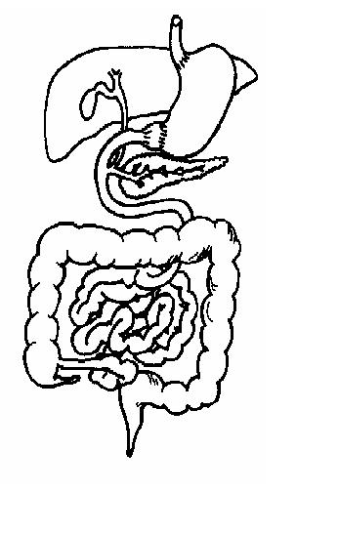
A
- The main function of the structure labeled ‘A’ is the

  - digestion and absorption of vitamins.
  - storage and release of faeces.
  - reabsorption of water.
  - emulsification of any lipids before absorption.

- A cell requires a high amount of glucose constantly and will absorb glucose from the plasma even when the plasma contains very little glucose. The process used in this situation is known as

  - diffusion.
  - osmosis.
  - active absorption.
  - active transport.

- A product of anaerobic respiration is

  - carbon dioxide.
  - lactic acid.
  - water.
  - creatinine.

- The cellular organelles which assemble polypeptides are called

  - ribosomes.
  - mitochondria.
  - endoplasmic reticulum.
  - golgi apparatus.

- The light microscope used in class this year is useful for viewing cells. Which of the following cell ‘sizes’ could be viewed easily and accurately using a light microscope?

  - Five millimetres.
  - Three thousand micrometres.
  - Fifty micrometres.
  - Fifty nanometres.

- Which of the following statements about cell division in the body is correct?

  - Meiosis only begins at puberty while mitosis occurs all the time.
  - Mitosis takes place in all body cells while meiosis only takes place in gametes.
  - Mitosis produces four cells while meiosis produces two cells.
  - Mitosis produces identical cells while meiosis produces non-identical cells.

- During childbirth there are a number of key events:

        - Dilation of the cervix.
        - Crowning.
        - Delivery of the placenta.
        - Breaking of the waters.
        - Contractions of the uterus.
        - Secretion of oxytocin by the pituitary gland.
        - Delivery of the Baby

Using the list above, the normal sequence of events is:

(a) a, e, f, b, d, c and g.
(b) f, e, a, d, b, g and c.
(c) a, b, d, f, e, g and c.
(d) e, f, a, b, d, g and c.

- A developing embryo has three primary germ layers: endoderm, ectoderm and mesoderm. Skeletal muscle and bone develops from the

  - endoderm.
  - mesoderm.
  - mesoderm and endoderm.
  - ectoderm.

Use the following diagram to answer questions 36 and 37

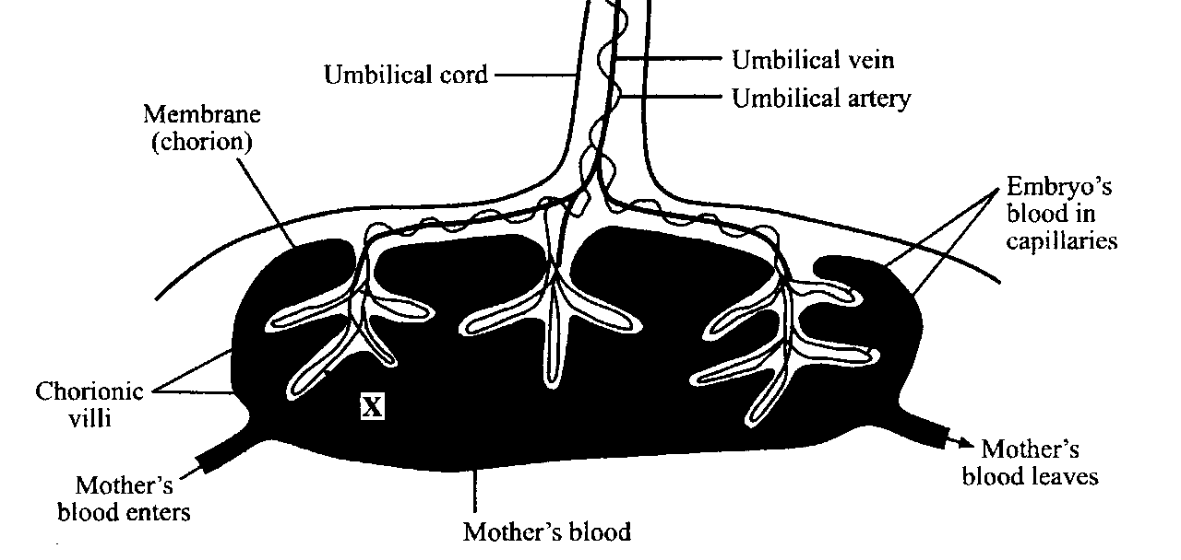

- The umbilical vein contains

- oxygenated blood.
- deoxygenated blood.
- oxygenated blood and nutrients.
- oxygenated blood and wastes.

- The main function of chorionic villi is

  - attaching the placenta to the uterus.
  - allowing blood to flow from mother to baby.
  - allowing the diffusion of nutrients and wastes.
  - enhancing the surface area of the chorion for fluid exchange between the baby and mother.

- The appearance of the first menstrual cycle during adolescence is known as

- fecundity.
- menarche.
- ovulation.
- menstruation.

- Arteriosclerosis occurs in

  - the cerebral arteries and is caused by a blood clot.
  - the coronary arteries during a heart attack.
  - all arteries and will lead to an increase in blood pressure.
  - the heart only.

- The quote, “such is life” would be consistent with which stage of dying described by Dr Kublar Ross?

  - Depression
  - Acceptance
  - Denial
  - Anger

END OF PART I

PART II Short Answers (80 marks)

Write answers to ALL questions on the ruled lines after each question or in the spaces provided within each table. Write your answers in blue or black ballpoint or ink pen.

QUESTION 41 (Total 7 marks)

(a) (i) Primates are classified into two (2) groups. What two ‘classification terms’ are used?

________________________________________________________________________________

________________________________________________________________________________

(2 marks)
(ii) What ‘features' are used to classify Primates into these two (2) groups?

________________________________________________________________________________

________________________________________________________________________________

________________________________________________________________________________

(3 marks)

(b) Classify the following primates into their respective groups using appropriate (primate) terminology:

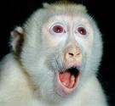  __________________________ | 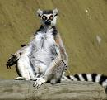  ______________________________
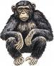  __________________________ | 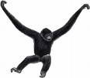  ______________________________

(2 marks)
QUESTION 42 (Total 8 marks)

(a) Label the regions of the vertebral column shown in the diagram below.

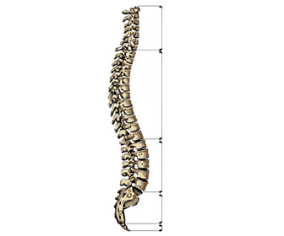
Region | Name
1

2

3

4

1
2
3
4
(2 marks)

(b) Other bones are connected to the vertebral column (diagram above) to provide the various skeletal functions like protection and movement. Identify the bones and state what region they occur in.

‘Bones’ | Region  (Number)
(2 marks)

(c) The human vertebral column is adapted for bipedal locomotion. Describe two adaptations and explain how they are suited to this form of locomotion.

________________________________________________________________________________________________________________________________________________________________________________________________________________________________________________
________________________________________________________________________________________________________________________________________________________________________________________________________________________________________________
(4 marks)
QUESTION 43 (Total 11 marks)

The diagram below shows the way in which gas exchange occurs in humans.

D
C

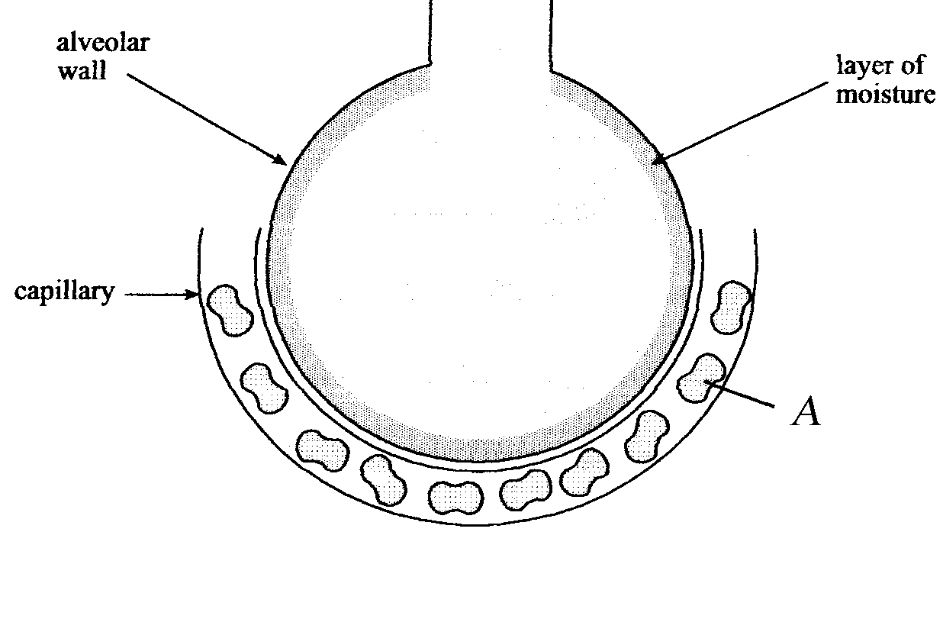
B
E
A

(a) Label the following structures or substances:

A_________________________ B______________________ (1 mark)

(b) What processes are indicated by?

C ________________________________________________________________________

E________________________________________________________________________

(2 marks)

(c) Like oxygen gas, carbon dioxide gas (CO₂) is also transported in the blood. Explain the different way(s) CO₂ is transported from the cells to the lungs.

________________________________________________________________________________________________________________________________________________________________________________________________________________________________________________
________________________________________________________________________________________________________________________________________________________________________________________________________________________________________________
(3 marks)

The diagram below shows microscopic sections of healthy (A) and diseased (B) lung tissue from two different adults.

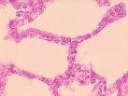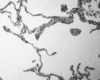
A B

(d) Describe TWO structural differences between the healthy and diseased lungs.

1_______________________________________________________________________________________________________________________________________________________________________________________________________________________________________________
2_______________________________________________________________________________________________________________________________________________________________________________________________________________________________________________
(2 marks)

(e) Why would the diseased lung work less efficiently?

________________________________________________________________________________________________________________________________________________________________________________________________________________________________________________
(2 marks)

(f) List ONE possible cause for this type of lung disease.

________________________________________________________________________________

(1 mark)

QUESTION 44 (Total 6 marks)

The following diagram represents a longitudinal section of the human heart.

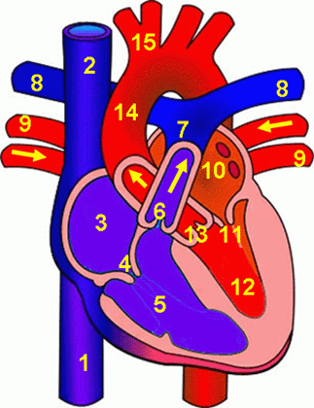

(a) Which of the blood vessels in the diagram above are involved in pulmonary circulation?

________________________________________________________________________________

(2 marks)

(b) Why is there a difference in the thickness of the walls of chambers 5 and 12?

________________________________________________________________________________________________________________________________________________________________________________________________________________________________________________
(2 marks)

(c) What are the differences in the blood flowing through 9 to 15 when compared to the heart structures 1 to 8?

________________________________________________________________________________________________________________________________________________________________________________________________________________________________________________
(2 marks)

QUESTION 45 (Total 8 marks)

The diagram below shows the main structures of the digestive system. Use this to answer questions (a) to (c).
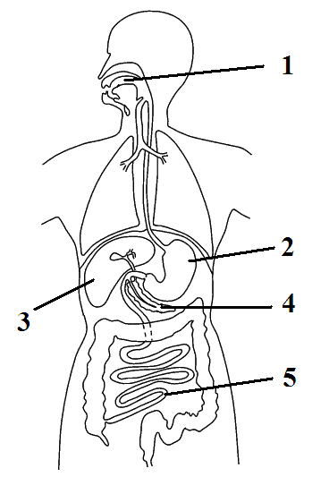

- In the table below, label the following structures:

Label | Structure
2
3
4
5
(2 marks)

(b) (i) Name one secretion produced by ‘3’ that assists the digestive process.

________________________________________________________________________________
(ii) What type of nutrient or food does this secretion act upon?
______________________________________________________________________________
(2 marks)
(c) Enzymes also assist the digestive process. Name TWO enzymes produced by the digestive organ ‘4’ and give their respective function.

Enzyme | Function

(4 marks)
QUESTION 46 (Total 14 marks)

Use the following diagram of the cell to answer questions (a) and (b).

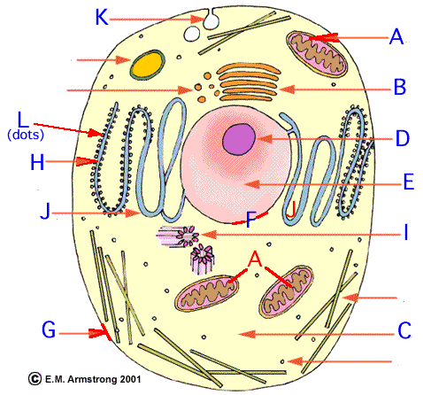
A Human Cell

(a) Give the functions of the following cell structures:

B __________________________________________________________________

F __________________________________________________________________

(2 marks)

(b) In the table below, explain differences between aerobic and anaerobic respiration and state where they occur in the cell.

 | Aerobic Respiration | Anaerobic Respiration
Difference 1
Difference 2
Location in Cell (letter)

(5 marks)
Cell division or Mitosis allows growth and repair in the body. Using the following diagram, identify and explain the main aspects of this process.

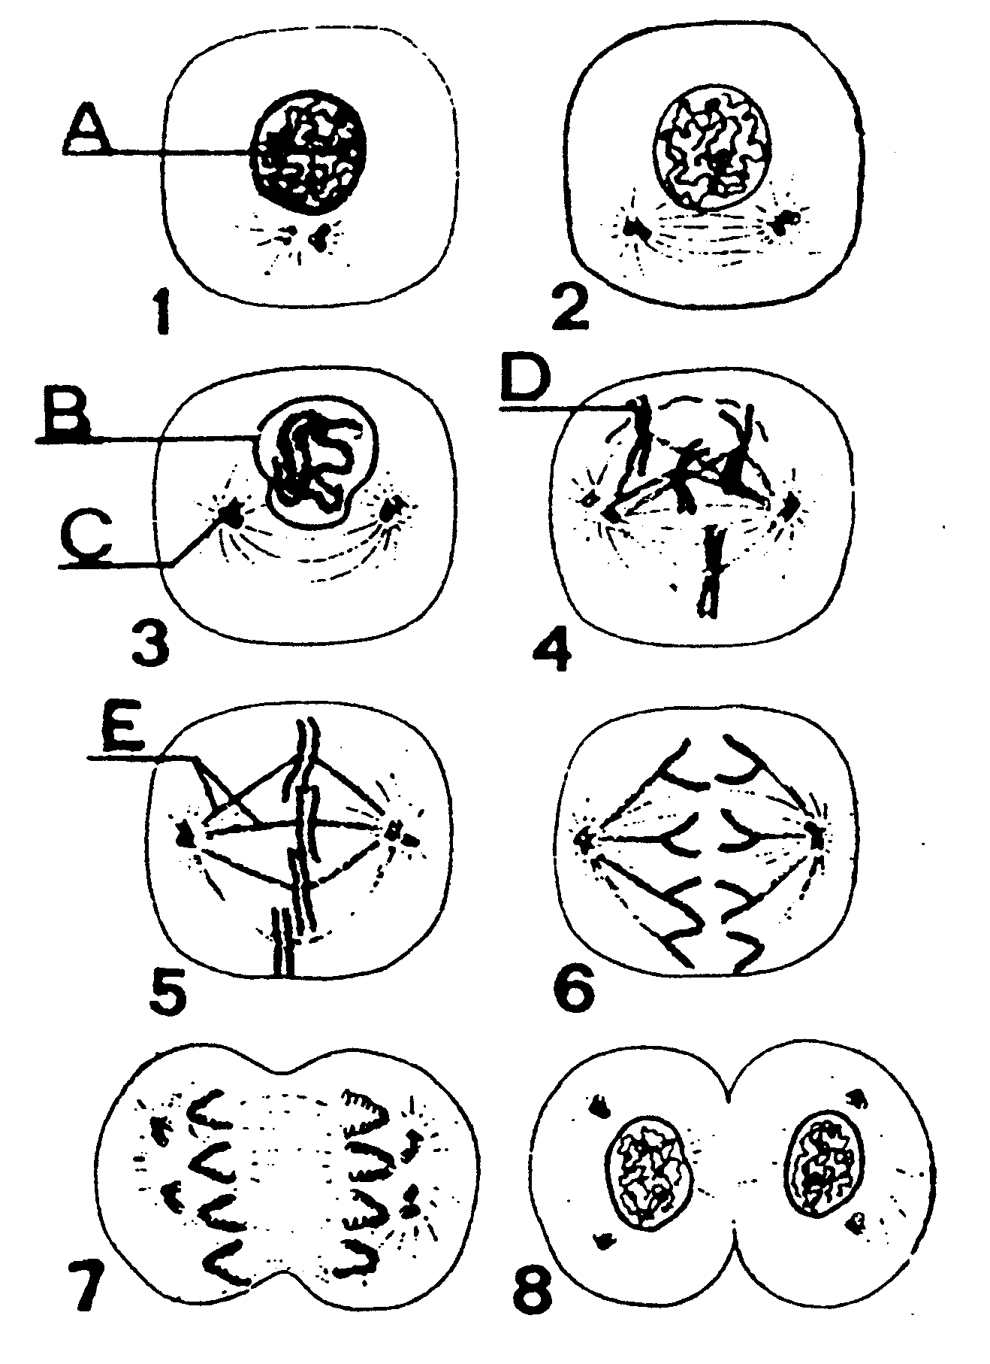

(c) Name structures C and E.

C______________________________ E________________________________

(2 marks)
(d) Identify (by number) the following mitotic stages which is best represented by a picture above:

Anaphase __________

Metaphase __________

Interphase __________
(3 marks)

(e) Why do chromosomes appear to ‘double’ during mitosis?

________________________________________________________________________________________________________________________________________________________________________________________________________________________________________________
(2 marks)

QUESTION 47 (8 marks)

The male and female reproductive systems have evolved to create new life. Questions (a) to (c) will examine some of the important processes involving both males and females.

(a) What are the functions of the following reproductive structures:

Structure | Function
Vas Deferens
Cowpers Gland
Uterine Tube/
Fallopian Tube
Cervix

(4 marks)

(b) During cold conditions, smooth muscular contractions in the scrotum causes the testicles to be raised towards the body. Why does this happen?

________________________________________________________________________________________________________________________________________________________________________________________________________________________________________________
(2 marks)

(c) List where the following reproductive processes occur in the table below:

Process | Reproductive Structure
Ovulation
Fertilisation
Implantation
Oogenesis

(2 marks)

QUESTION 48 (Total 10 marks)

The following table lists the ‘growth’ of the embryo and foetus during pregnancy.

Time (weeks) | Height (mm) | Mass (gms)
5 | 50 | 50
12 | 110 | 150
18 | 175 | 450
24 | 240 | 950
28 | 270 | 1500
32 | 320 | 2700
40 | 390 | 3600

(a) Graph the data on the graph paper provided below. (4 marks)


(A spare grid can be found on page 33)

(b) Label the following information on your graph:

- Key milestones of development-heart beat, limb buds and ossification.

(ii) Embryo and foetal development stages.

(4 marks)

(c) A developing baby’s weight almost doubles in the last 12 weeks before birth. What is the significance of this weight gain?

________________________________________________________________________________________________________________________________________________________________________________________________________________________________________________
________________________________________________________________________________________________________________________________________________________________
(2 marks)

QUESTION 49 (Total 8 marks)
Growth rate is defined as the increase in height each year. The graph below shows the changes in the growth rate in a male from birth to the age of fifteen years of age.
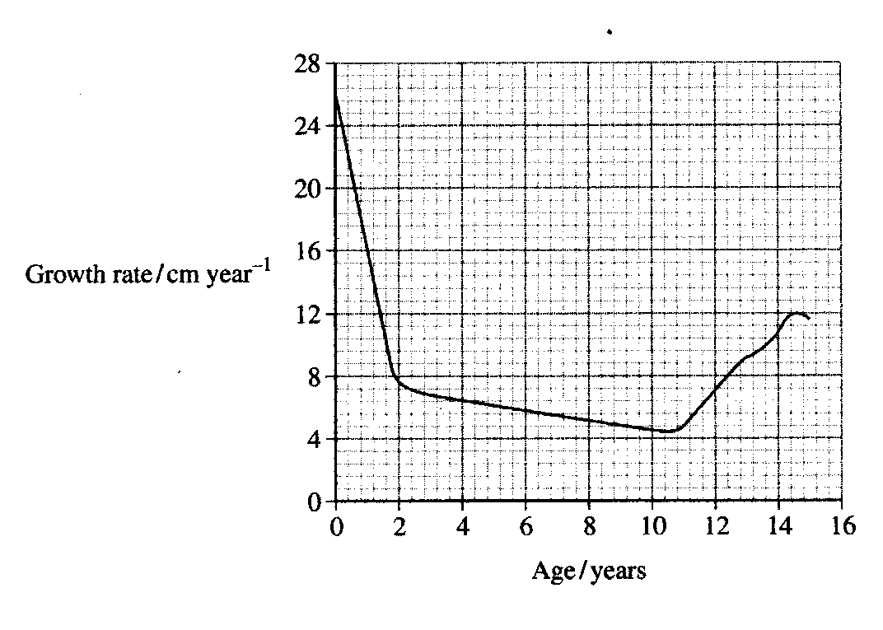
(a) Identify two ages when the male’s age growth rate was 8cm per year.

- __________________

(ii) __________________
(2 marks)
(b) Draw or sketch the female growth rate on the graph above. (2 marks)
(c) List the hormone(s) in both genders that are responsible for this increase in growth.
________________________________________________________________________________________________________________________________________________________________
(2 marks)
(d) Distinguish between the terms puberty and adolescence.
________________________________________________________________________________________________________________________________________________________________________________________________________________________________________________
(2 marks)
END OF PART II

PART III Extended Short Answer (40 marks)

Answer ONE question from SECTION A and ONE question from SECTION B. Illustrate your answers with diagrams where appropriate. Up to TWO MARKS may be deducted for poorly structured answers: that is, answers in point form or diagrams not explained in the text of your answers. DO NOT WRITE ANSWERS IN PENCIL. Write your answers in the Extended Answer Booklet supplied.

SECTION A

ANSWER EITHER QUESTION 50 OR QUESTION 51 – NOT BOTH

QUESTION 50 (Total 20 Marks)

(a) The human skeleton is classified into the axial and appendicular skeletons. Discuss the bones make up each ‘skeleton’ and relate this to their main function(s) and movement(s).

(10 marks)

(b) Briefly describe the inhalation and exhalation breathing mechanisms during rest. Explain how the structure of the alveoli allows for efficient gas exchange. During high activity or exercise, the rate and depth of breathing changes to allow efficient gas exchange. Explain how this is achieved. (10 marks)

OR

QUESTION 51 (Total 20 Marks)
(a) List FIVE evolutionary primate trends. Describe each one illustrating your answer with an example from a primate group.
(10 marks)

(b) You consumed one fried egg and toast for breakfast this morning. Discuss the fate of the fried egg and toast in your digestive system. In your response include the

- main nutrient groups in a fried egg and bread.
- digestive area(s) where chemical digestion occurs.
- final products of digestion.
(10 marks)

SECTION B

ANSWER EITHER QUESTION 52 OR QUESTION 53 – NOT BOTH

QUESTION 52 (Total 20 Marks)

    - During the late 1970’s, Dr Cecil Jacobson injected a course of ‘HCG’ and donor sperm into women in an attempt to cause pregnancy. All patients returned a ‘positive’ pregnancy test. Unfortunately, after 13 weeks a spontaneous abortion or ‘miscarriage’ occurred. Several years later, after a medical investigation, it turned out that Dr Jacobson’s patients were never pregnant! What is ‘HCG’? Explain the roles of oestrogen, progesterone and ‘HCG’ in a normal and successful fertilisation leading to pregnancy. (10 marks)

(b) Enzymes are specialised chemicals that are required by cells in very small amounts to maintain cellular functions. Discuss the role of enzymes in cells, how enzymes work and the optimal conditions for enzyme functioning. (10 marks)
OR

QUESTION 53 (Total 20 Marks)

- Describe the three stages of birth including the approximate length of each stage. After birth, significant change occurs to the baby to prepare their for life outside the womb. Select TWO of the changes that occur and describe why they occur.

(10 marks)

- Discuss the characteristics of ageing and the major effects on the body systems.

(10 marks)

END OF PAPER


(Spare grid for question 48 (a))

